Capstone   
Demo

To evaluate:

First Install <https://www.npmjs.com/>

Unzip file.

In command line or git bash type:

npm install truffle

npm install testrpc

then

testrpc

don’t close this window, in a new command window:

cd ethvote

truffle migrate

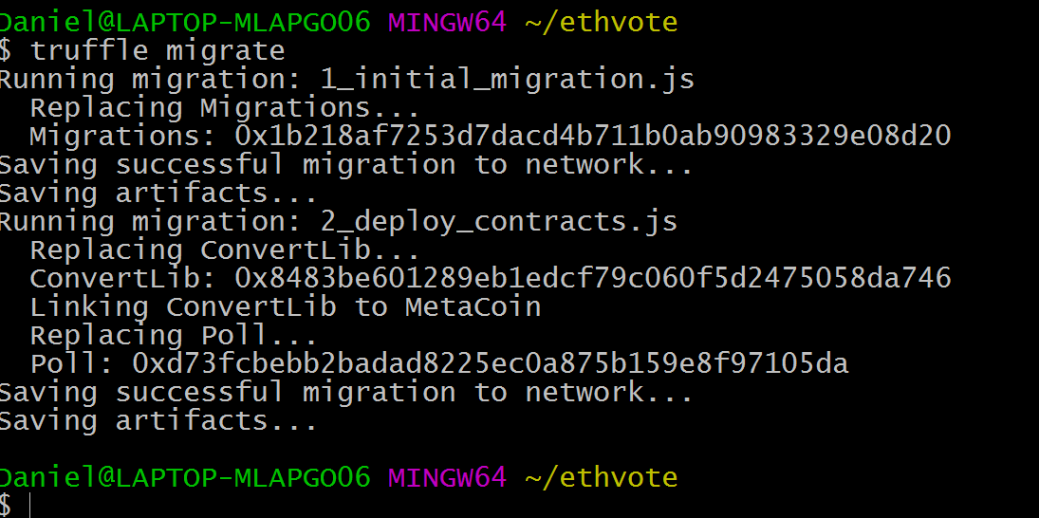

Copy the Poll: address

next

cd UI

npm install

npm start

and a browser will open up, there are many dependencies so the installation my take some time.

finally replace the address in my code, file UI\src\components\web3helper , with copied one.

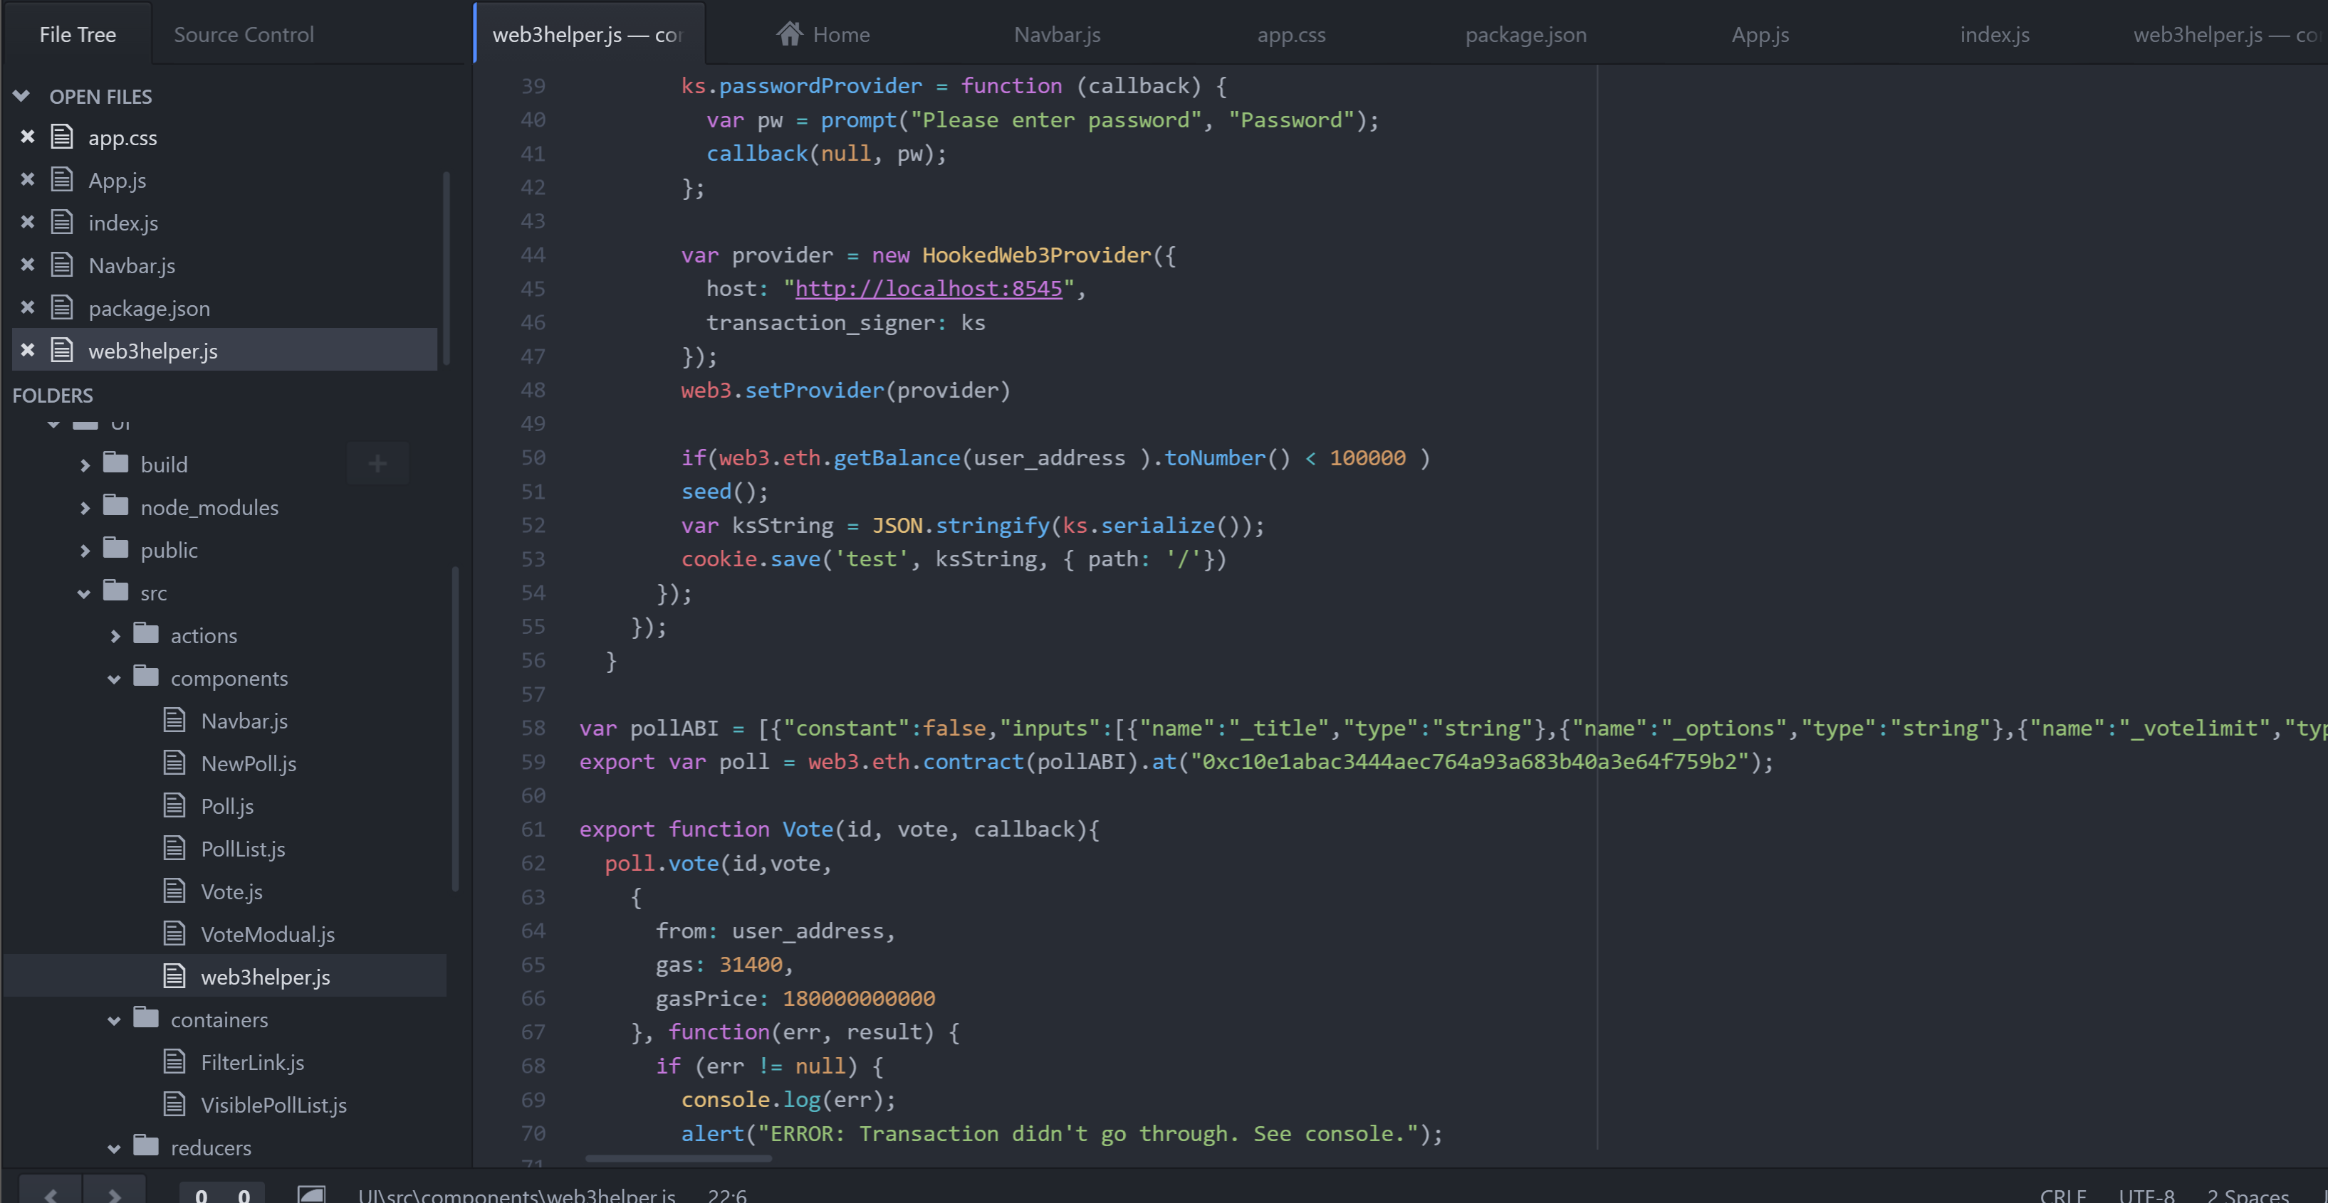

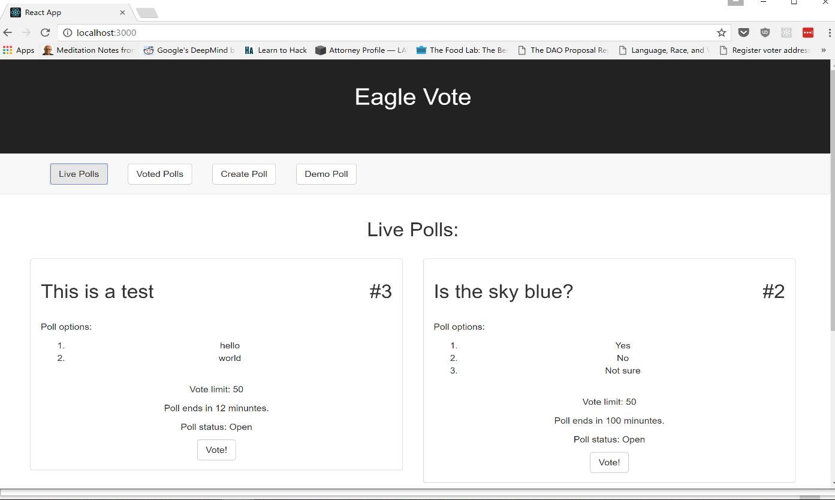Demo:

Vote on a particular poll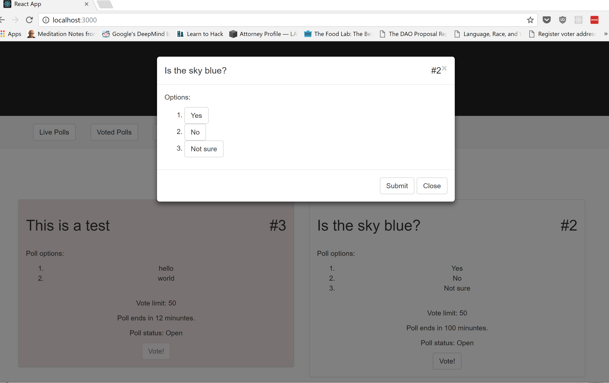

Filter polls based on passed votes

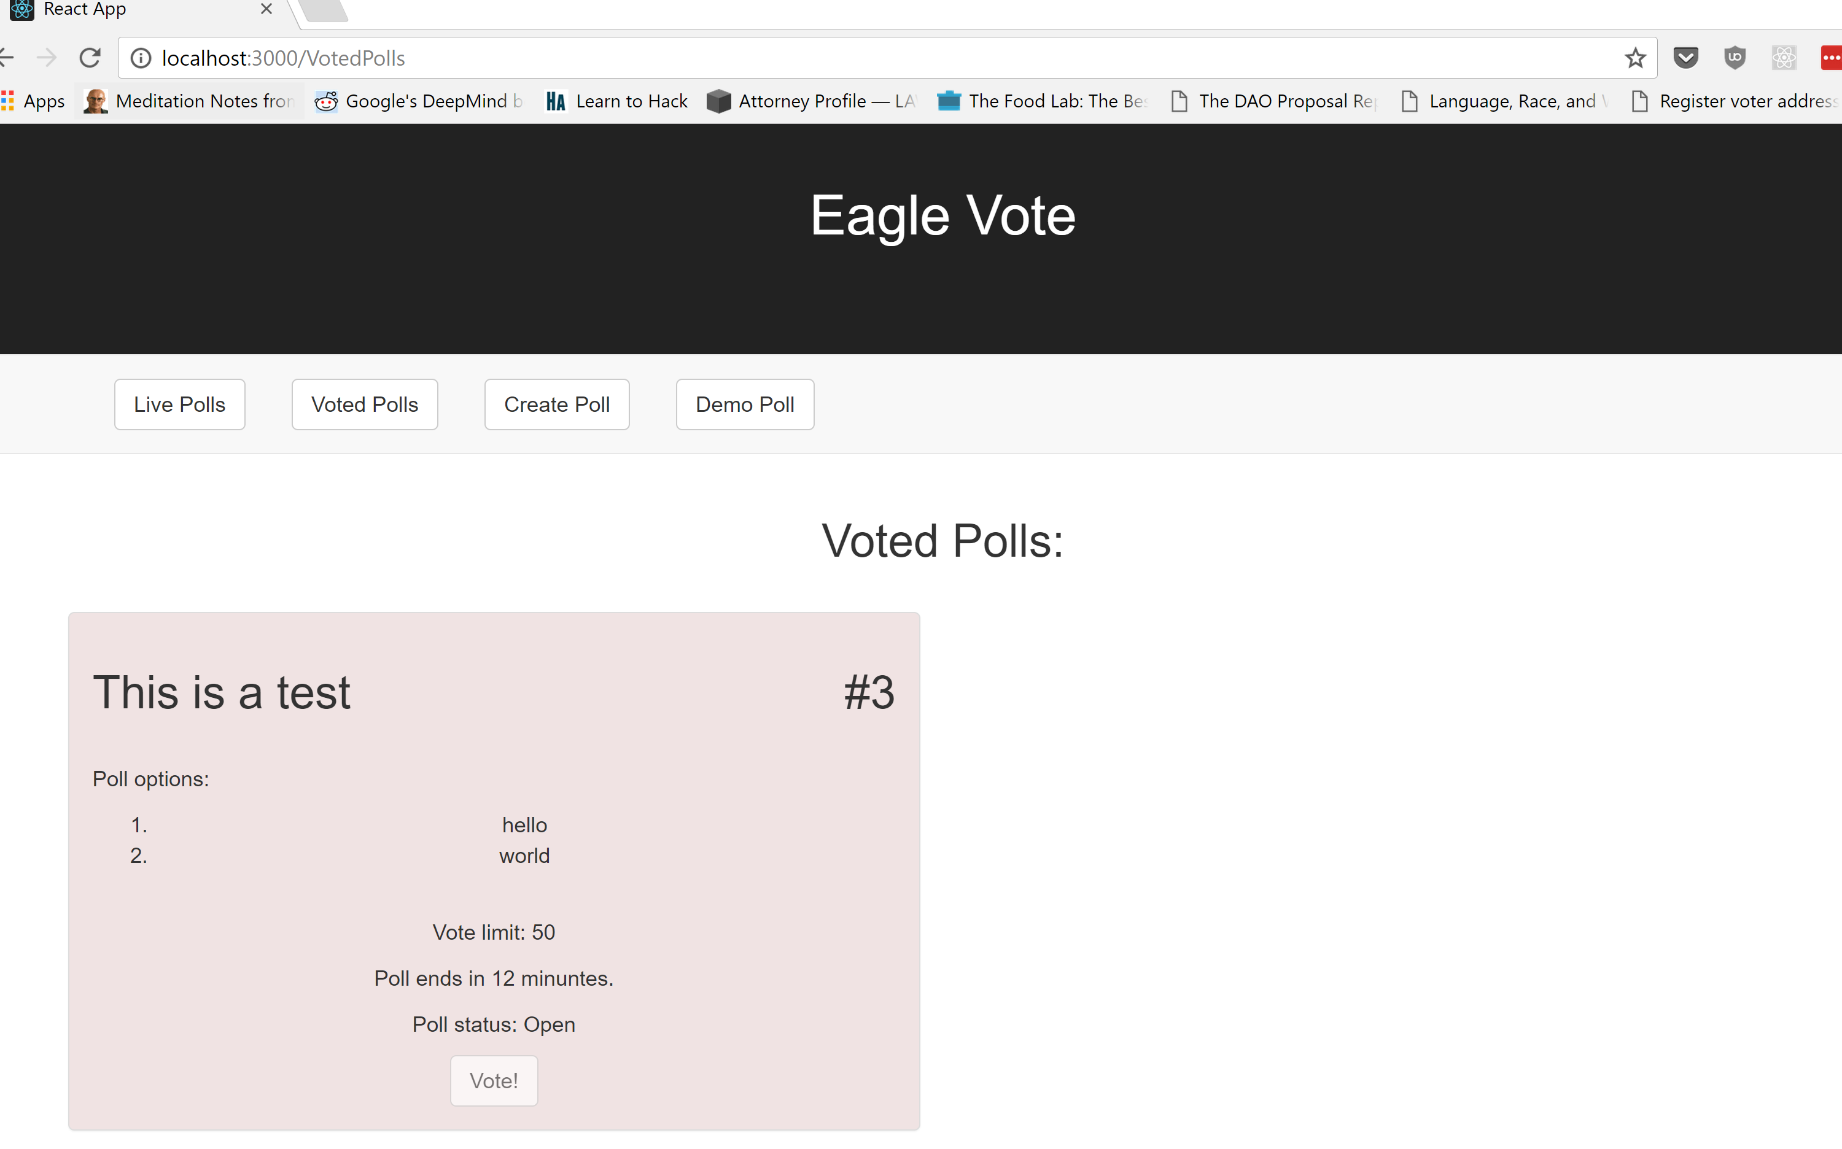

And create a new custom poll

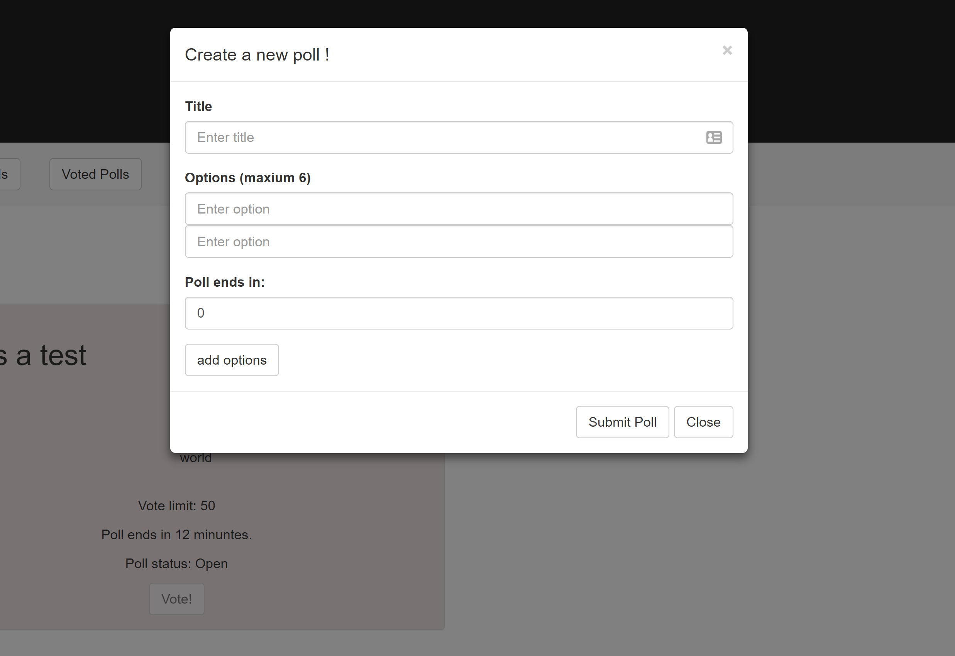

Backend blockchain

